**Project Overview**

**Introduction:**

Sometimes we are in need of address book which can be accessed from anywhere like during our travelling sections. It’s the online address book which facilitates you to search any saved records using web from any location. This project has been developed using Java and Data structure framework collections. The main objective for developing this project is to managing user contact details, phone numbers, address and email addresses. It’s not only saving records, among this, you can also share your address book with other by granting appropriate permissions. This address book will work as insurance partner for your contact details. This system will keep your records secure and can be accessed from any location and represent the output as per your requirement whenever you’re required. It’s the address book, which can be available anytime, anywhere and can be accessed from multiple computers with proper authorization. This application is very easy and simple to access at Java. It is a very simple source code. It will simplify the task and reduce the paper work.

The following functionalities which has been implemented in my project:

* Used Java API for RESTful Web Services (Jax-RS)
* Built a client application that sends all the HTTP requests, i.e., POST/PUT/GET/DELETE
* Built a server application using tomcat server, that responds to all of the HTTP requests, i.e., POST/PUT/GET/DELETE
* The client application will parse the response using XMLPullParser and showing outputs to the GUI" + "A tomcat server (9) that responds to all of the HTTP requests GET/PUT/POST/DELETE"
* The data in the response will be taken from an HSQLDB database and the table name is ‘addressbook’.

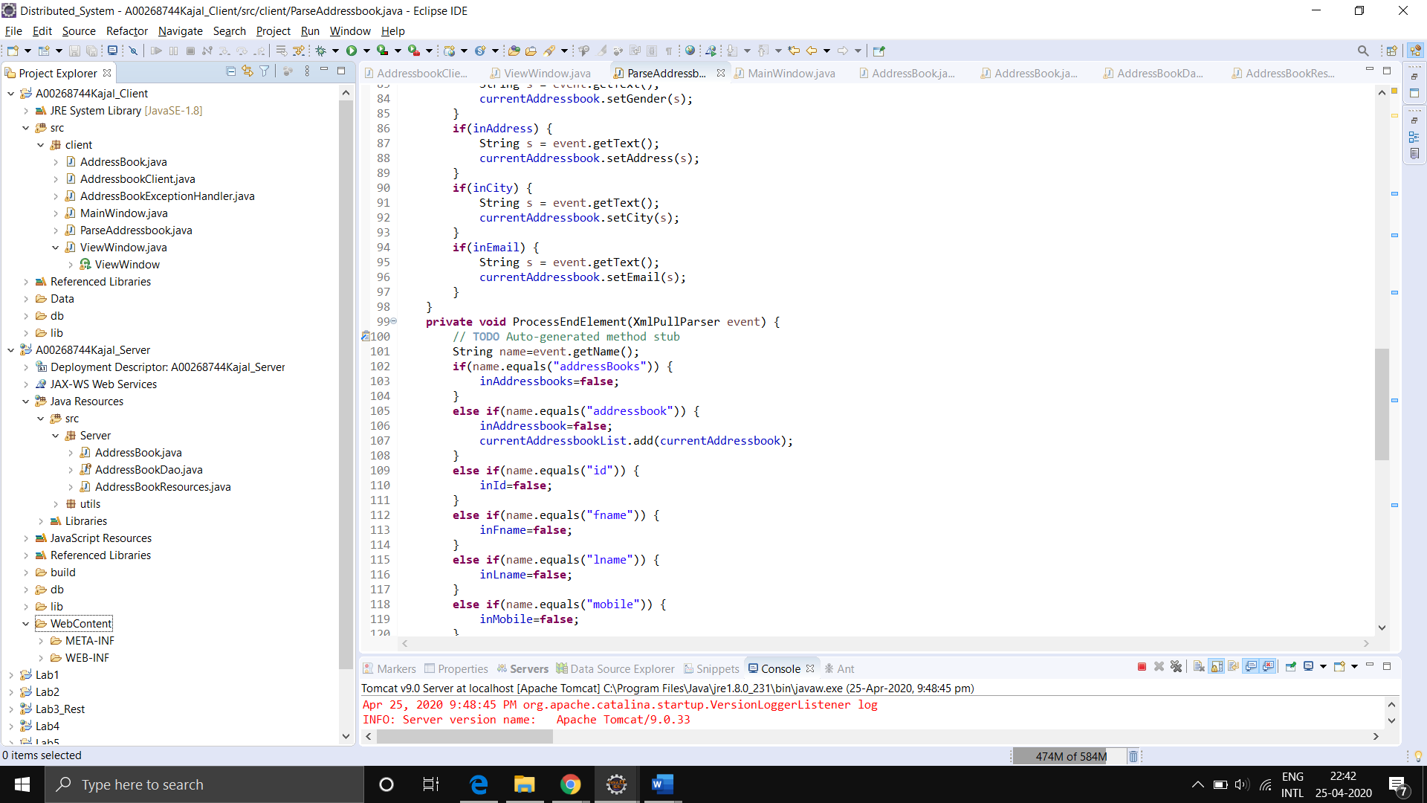

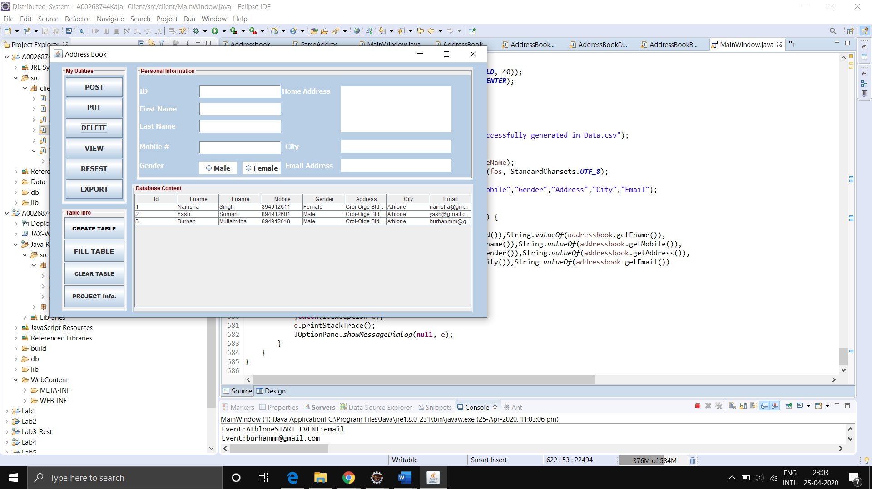

**Main Functions:**

POST: Enter the details of a person and submit it to the server to store in the database table.

PUT: Enter the details of the user that needs to be modified on the server using id and the table is updated.

GET: Choose the first name from combo box and get the all details of that entity into the table.

VIEW: Basically, retrieves all the information about a user from the server.

RESET: It clear all the text fields.

EXPORT: It generates all the personal information stored on the server into a csv file.

FILL Table: Creates three entities automatically for the table and submit it to the server to store.

CREATE Table: Runs code to create the hsqldb table (Addressbook) if it doesn’t exist.

CLEAR Table: Runs the code to delete the hsqldb table from the server.

PROJECT Info- Small popup box with student number and name.

**Requirement 1:**

Tables created using code at runtime plus code to select, insert, update and delete data.

**Completion**

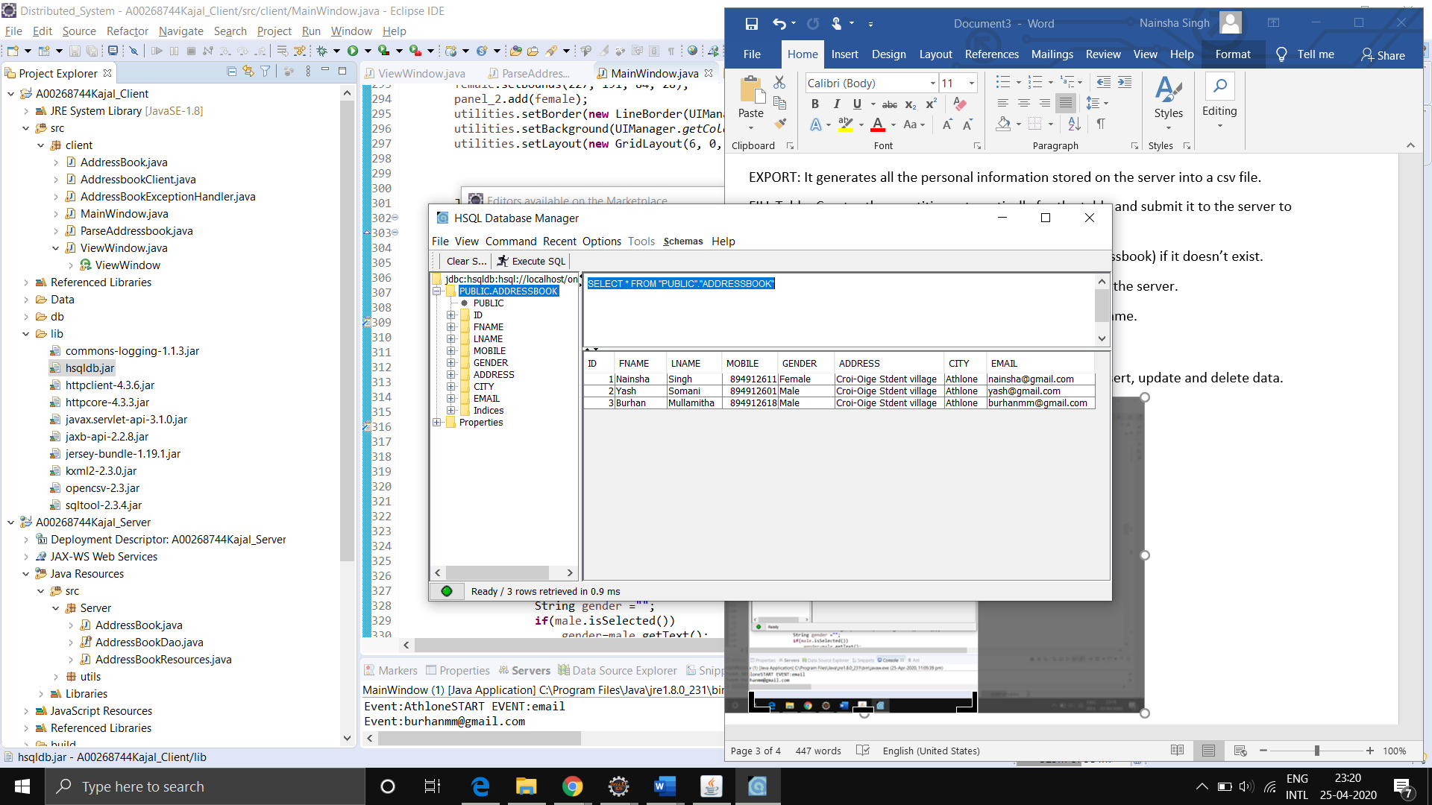

Fig: This is how my hsqldb data looks like.

**Creation SQL:**

"CREATE TABLE IF NOT EXISTS addressbook (id INTEGER IDENTITY, fname VARCHAR(32) NOT NULL, lname VARCHAR(32) NOT NULL , mobile INTEGER , gender VARCHAR(32), address VARCHAR(220), city VARCHAR(32), email VARCHAR(32))"

**Steps for First Time Use:**

1. **Run Tomcat Server.**
2. **Run Ant and the hsqldb sever.**
3. **Client GUI Application-> Create Tables.**
4. **Client GUI Application -> Fill Tables.**

First time when the application gets started user must start the server and run the client gui application and then click on the create table button to set up the addressbook table into the database so that we can start performing our functionalities.

**Requirement 2:**

" Built a server application using tomcat server, that responds to all of the HTTP requests, i.e., POST/PUT/GET/DELETE"

Essentially, I start off by creating the POJO or the Java Beans class, in my case, AddressBook.

I will also declare the XMLROOTElement here.

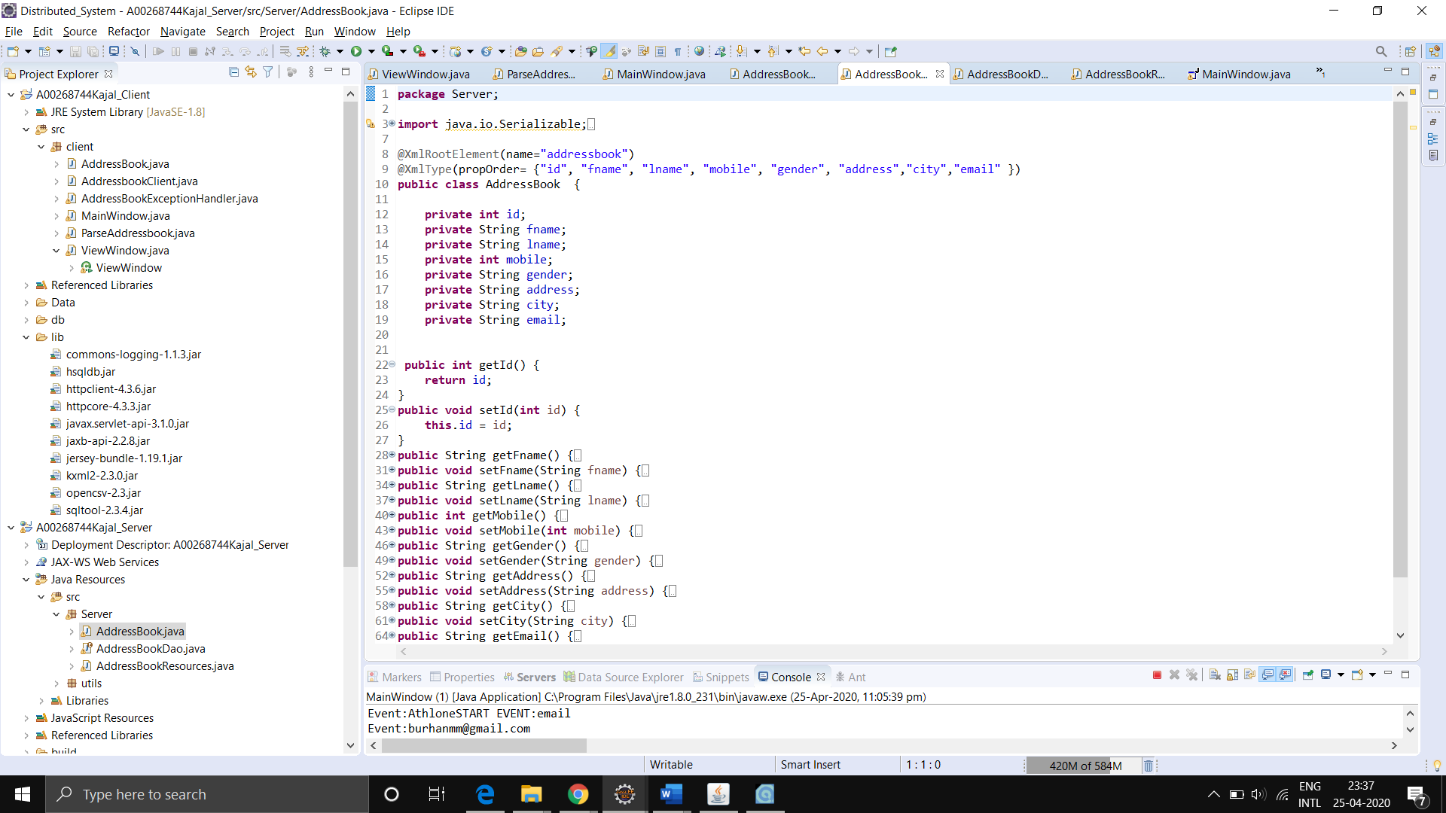

A Resource class that will basically execute different functions based on the URL or the http requests that are made.

@GET

@Produces({ MediaType.***APPLICATION_XML***, MediaType.***APPLICATION_JSON***, MediaType.***TEXT_XML*** })

**public** ArrayList<AddressBook> getContacts()

This GET function will return all the addressbook details from the database in the form of XML.

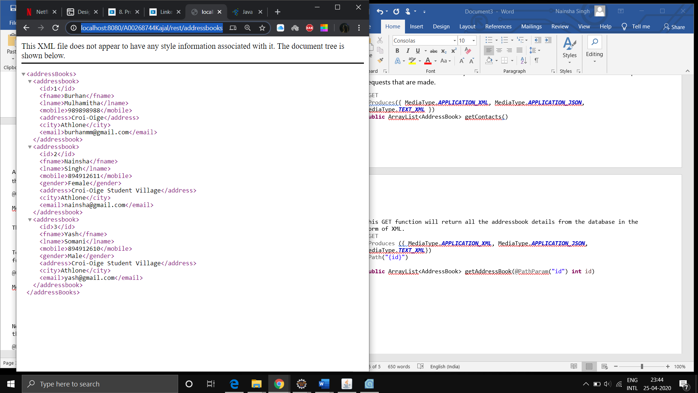

To retrieve only 1 addressbook according to the id, we will declare the following function.

@GET

@Produces ({ MediaType.***APPLICATION_XML***, MediaType.***APPLICATION_JSON***, MediaType.***TEXT_XML***})

@Path("{id}")

**public** ArrayList<AddressBook> getAddressBook(@PathParam("id") **int** id)

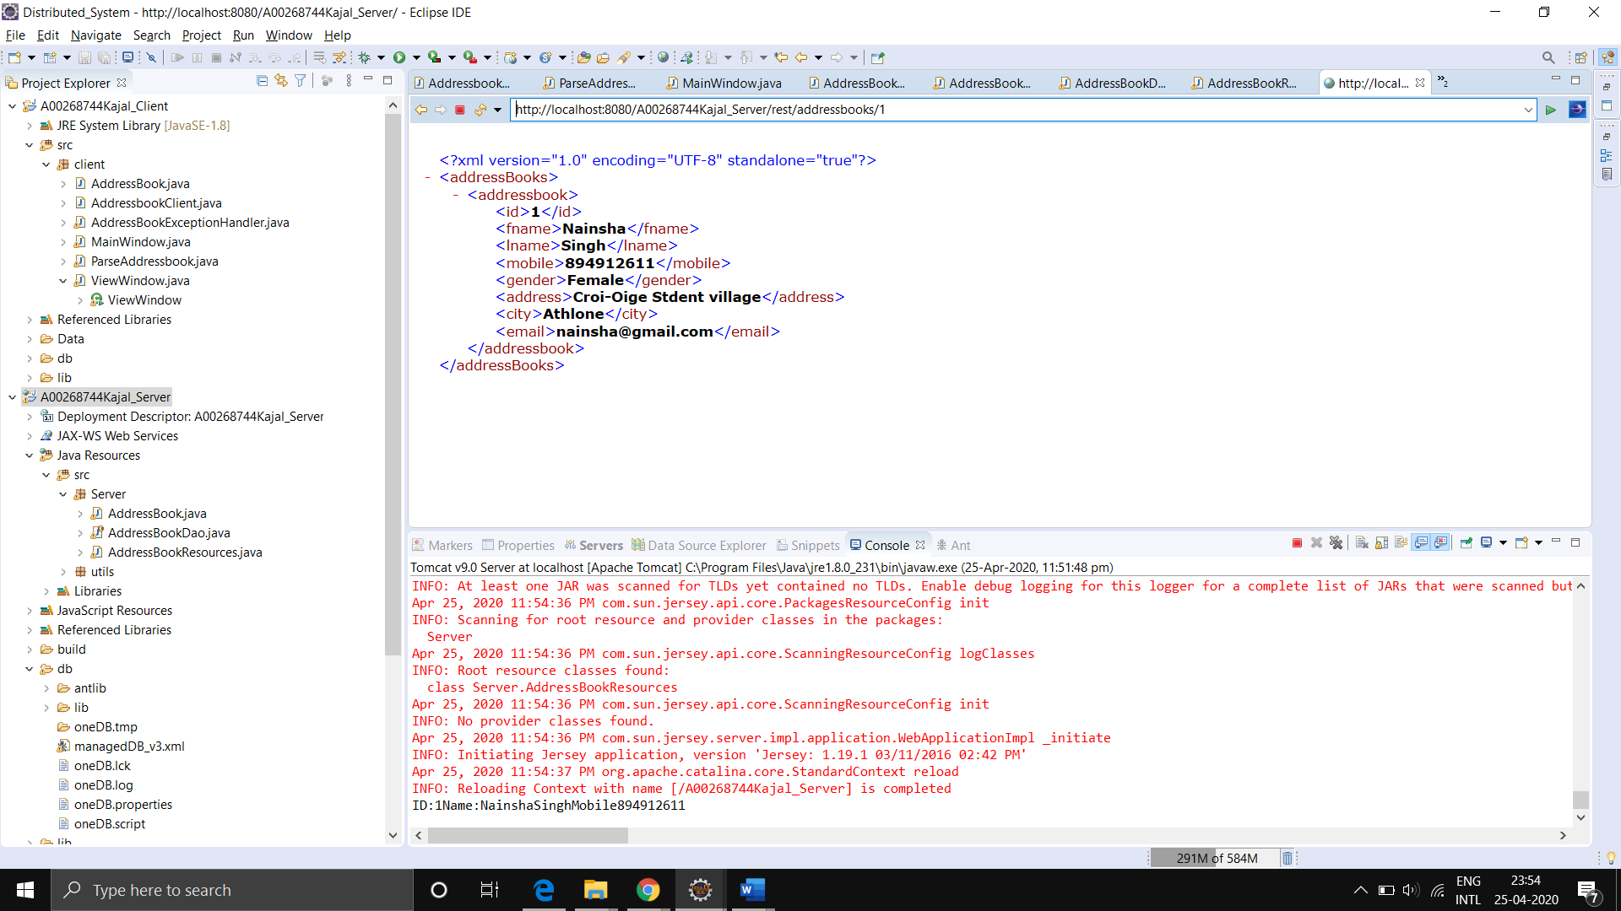

Now for handling @POST HTTP Request, we will create this following code to handle all the parameters.

@POST

@Produces({ MediaType.***TEXT_HTML*** })

@Consumes({ MediaType.***APPLICATION_FORM_URLENCODED*** })

**public** **void** postAddressbook(@FormParam("id") **int** id,

@FormParam("fname") String fname,

@FormParam("lname") String lname,

@FormParam("mobile") **int** mobile,

@FormParam("gender") String gender,

@FormParam("address") String address,

@FormParam("city") String city,

@FormParam("email") String email)

Lastly, for DELETE Request, I will retrieve the addressbook I need to delete from the path parameter.

@DELETE

@Produces(MediaType.***TEXT_HTML***)

@Path("{id}")

**public** **void** deleteAddressbook(@PathParam("id") **int** id)

**Requirement 3:**

"GUI that handles the GET/PUT/POST/DELETE actions"

**Completion**

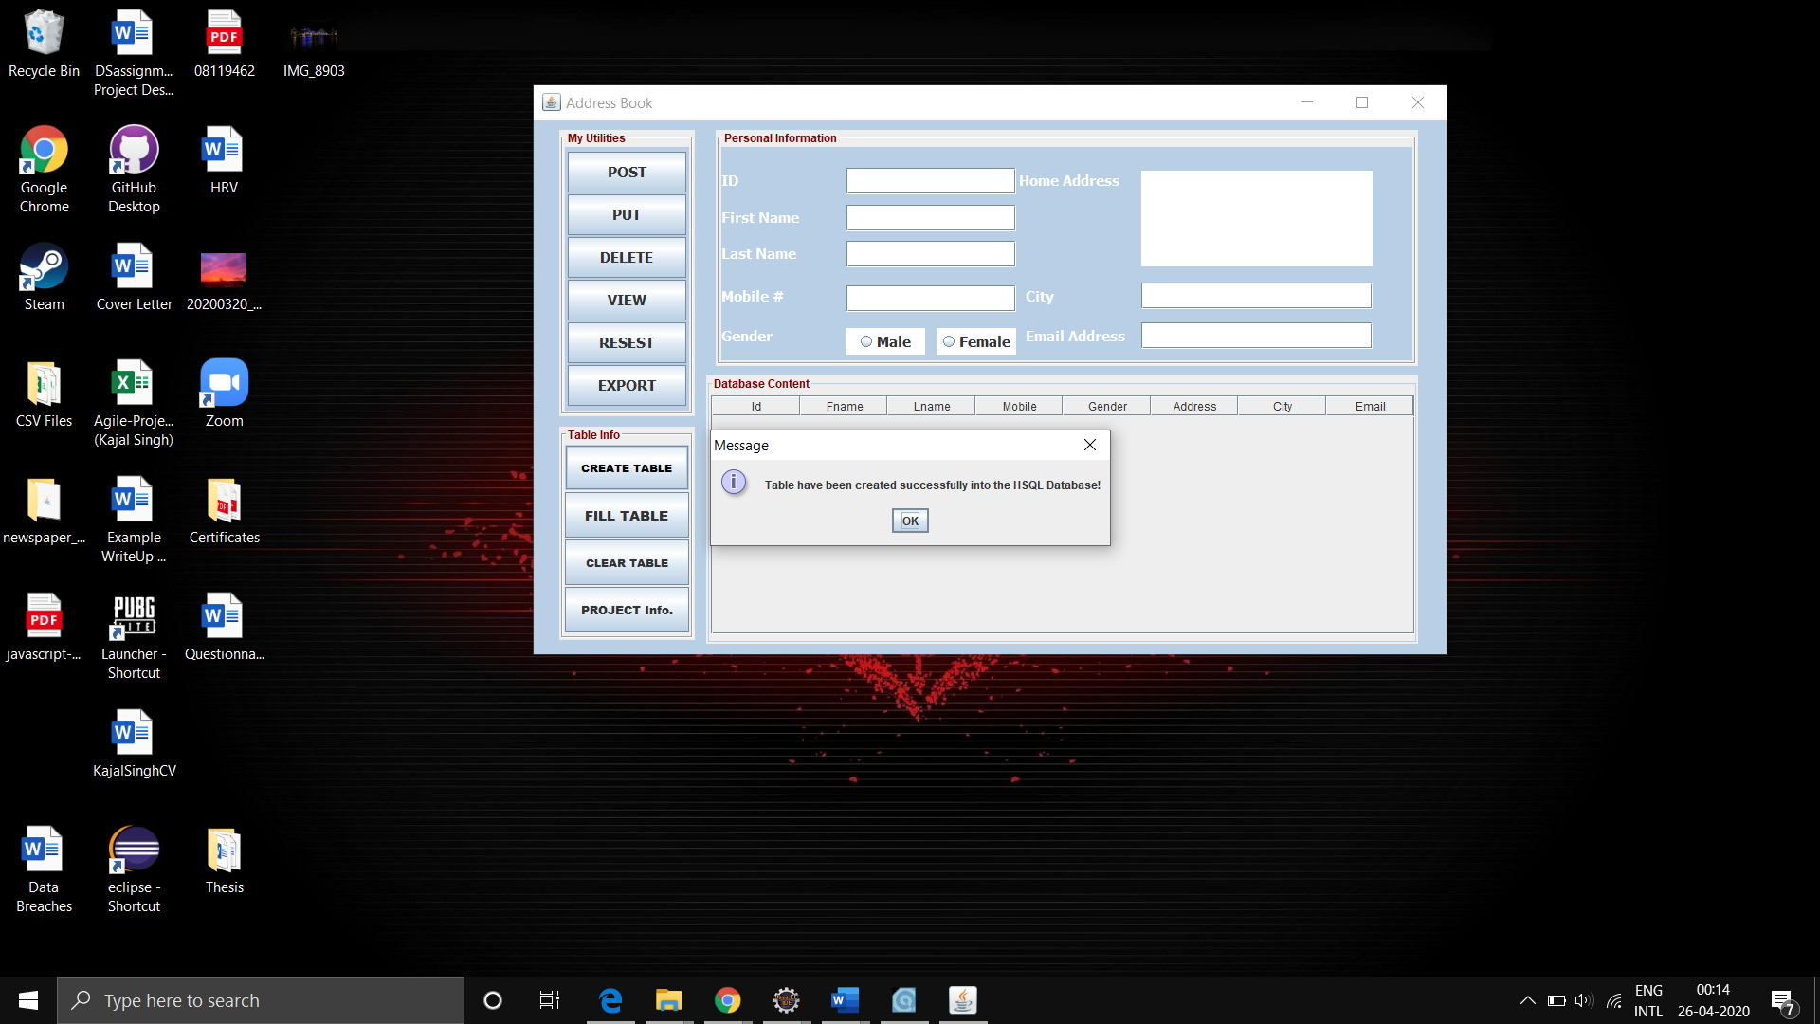

As you can see, here Table have been created successfully

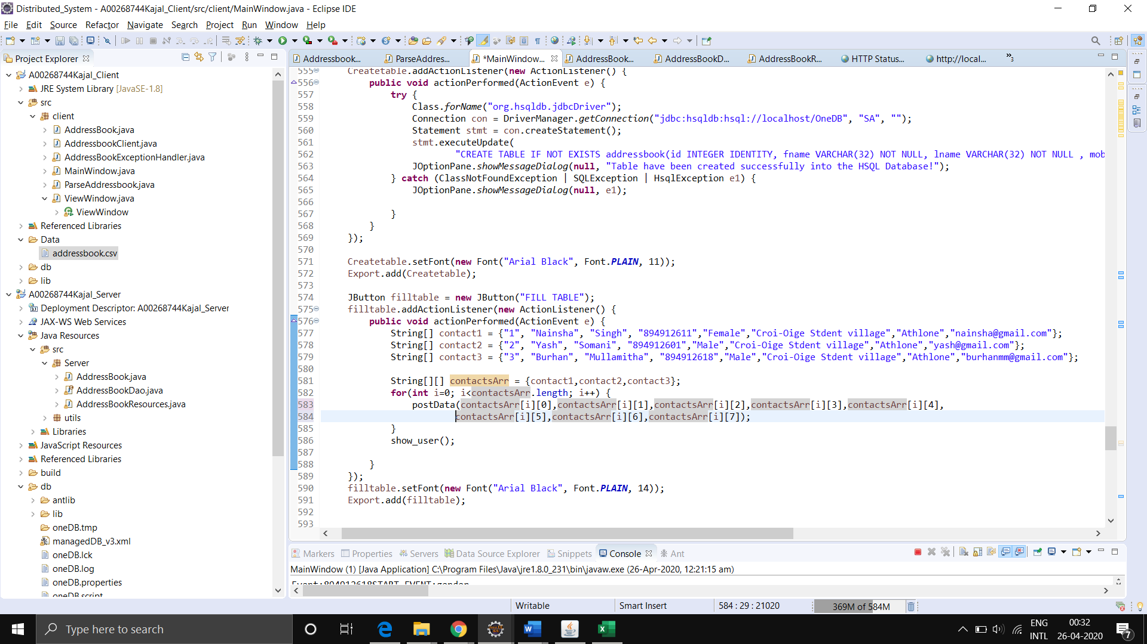

Code snippet to fill table.

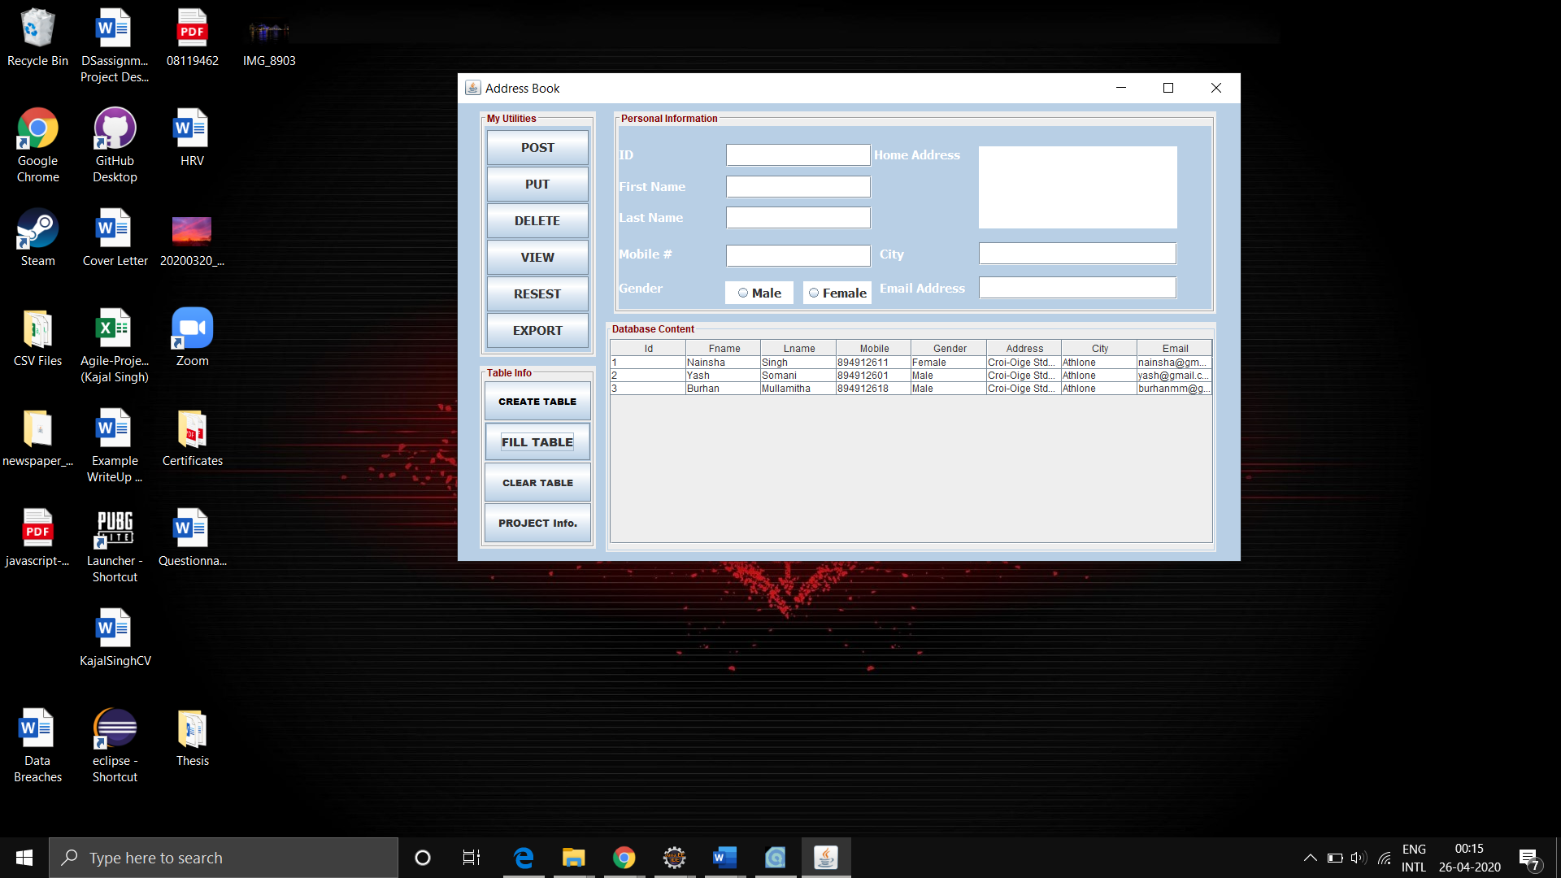

After creating table click on the fill table button, as you can see here table has been automatically filled with three fields.

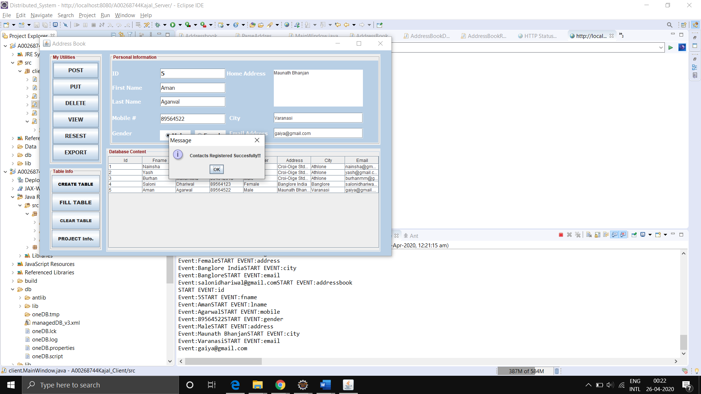

So we send all the parameters in a list format and using a HTTP Post request, we call the url with this list to the server to insert the data in the database. We send all the parameterts in the nameValuePairs and then set the HTTPPost Entity with this list so these go as the form parameters in the HTTP Request.

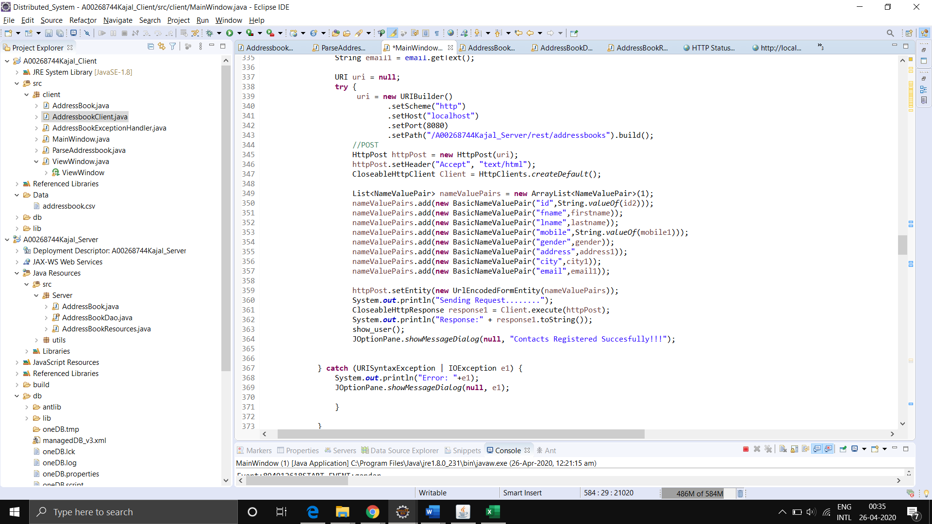

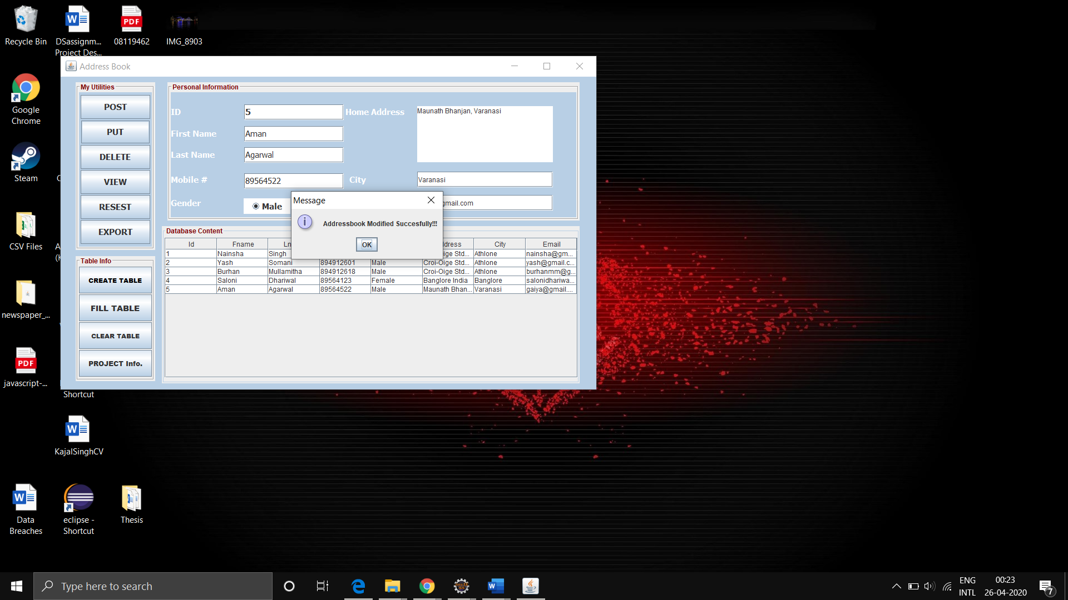

We make the put request again by storing all the parameters in the list and storing them in such a manner.

We make the PUT Request by calling the url and passing the parameter of the id in the Path.

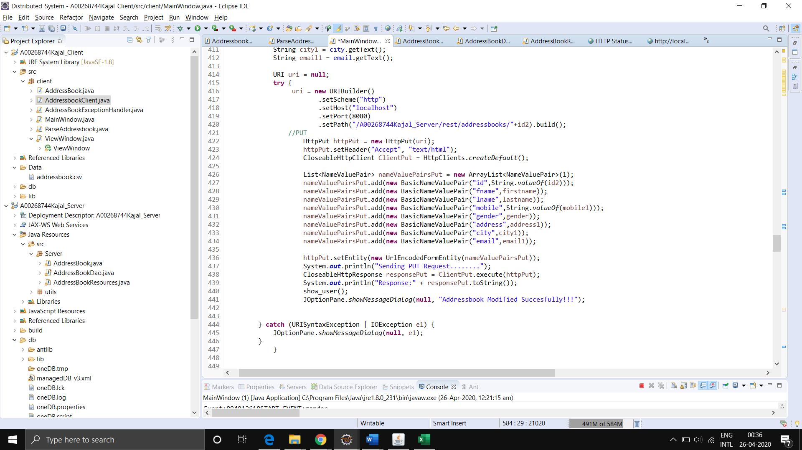

Essentially, we use all the parameters from the GUI and store them in the nameValuePairs and send them along with our PUT Request.

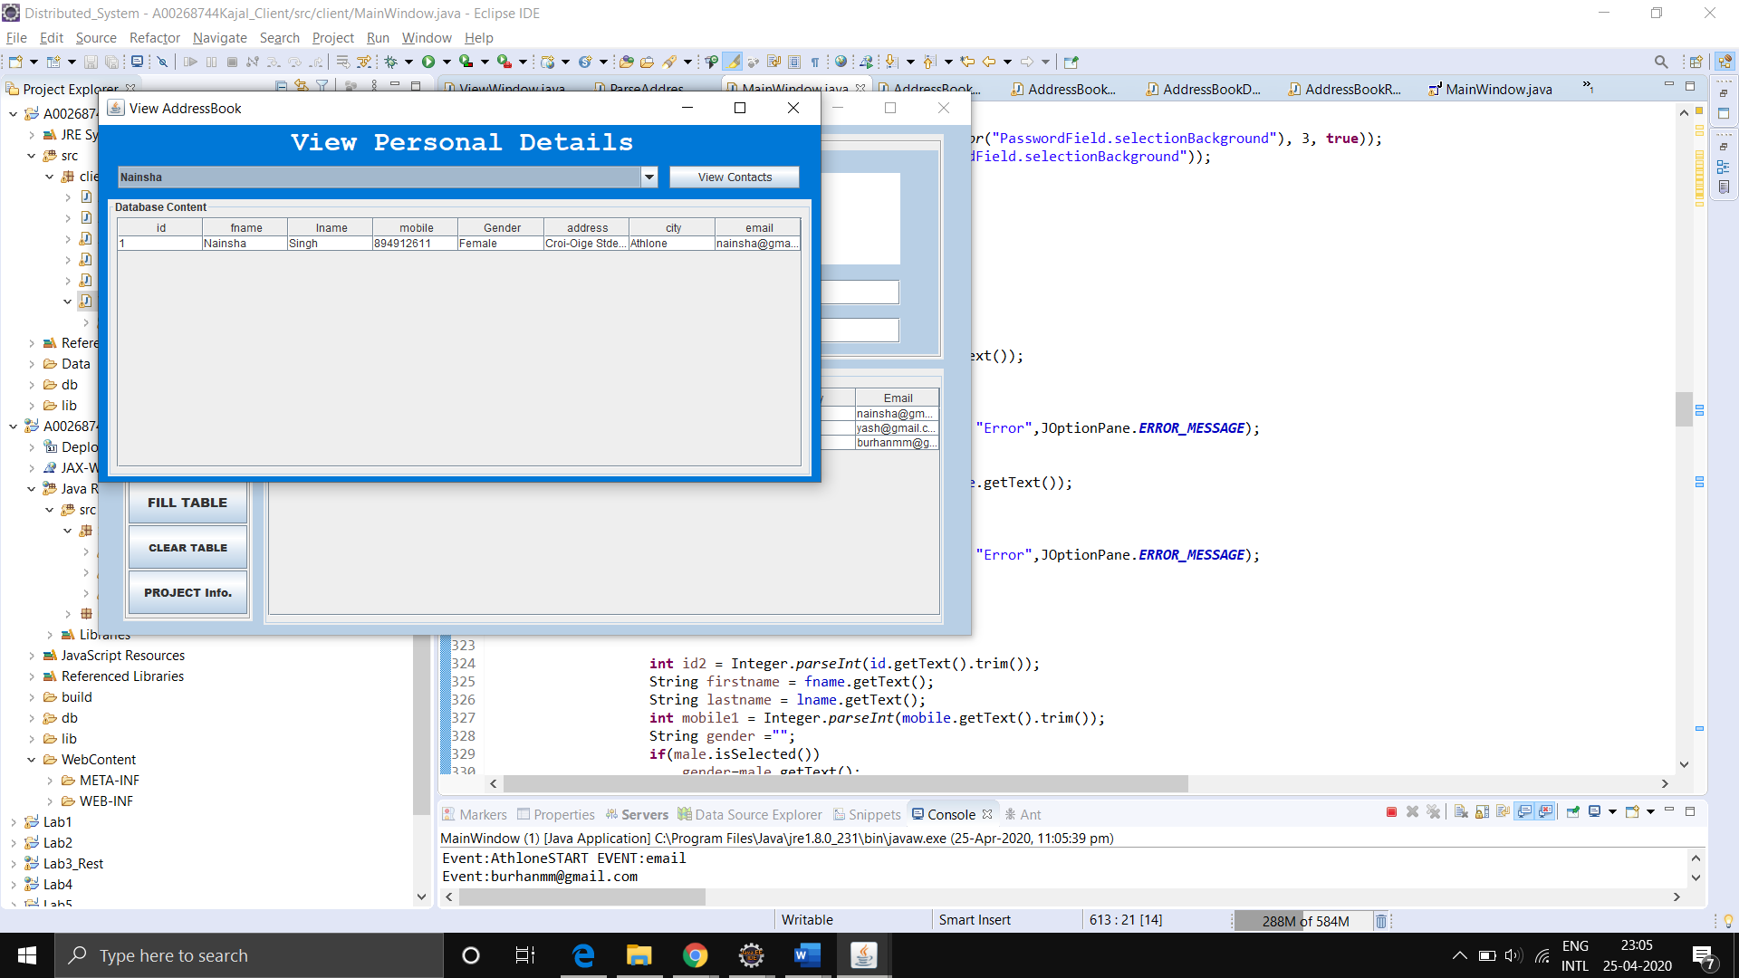

Here, we pass the Addressbook id that we need to retrieve from the server in the URL itself as a path parameter and print the data we received and displayed on the GUI.

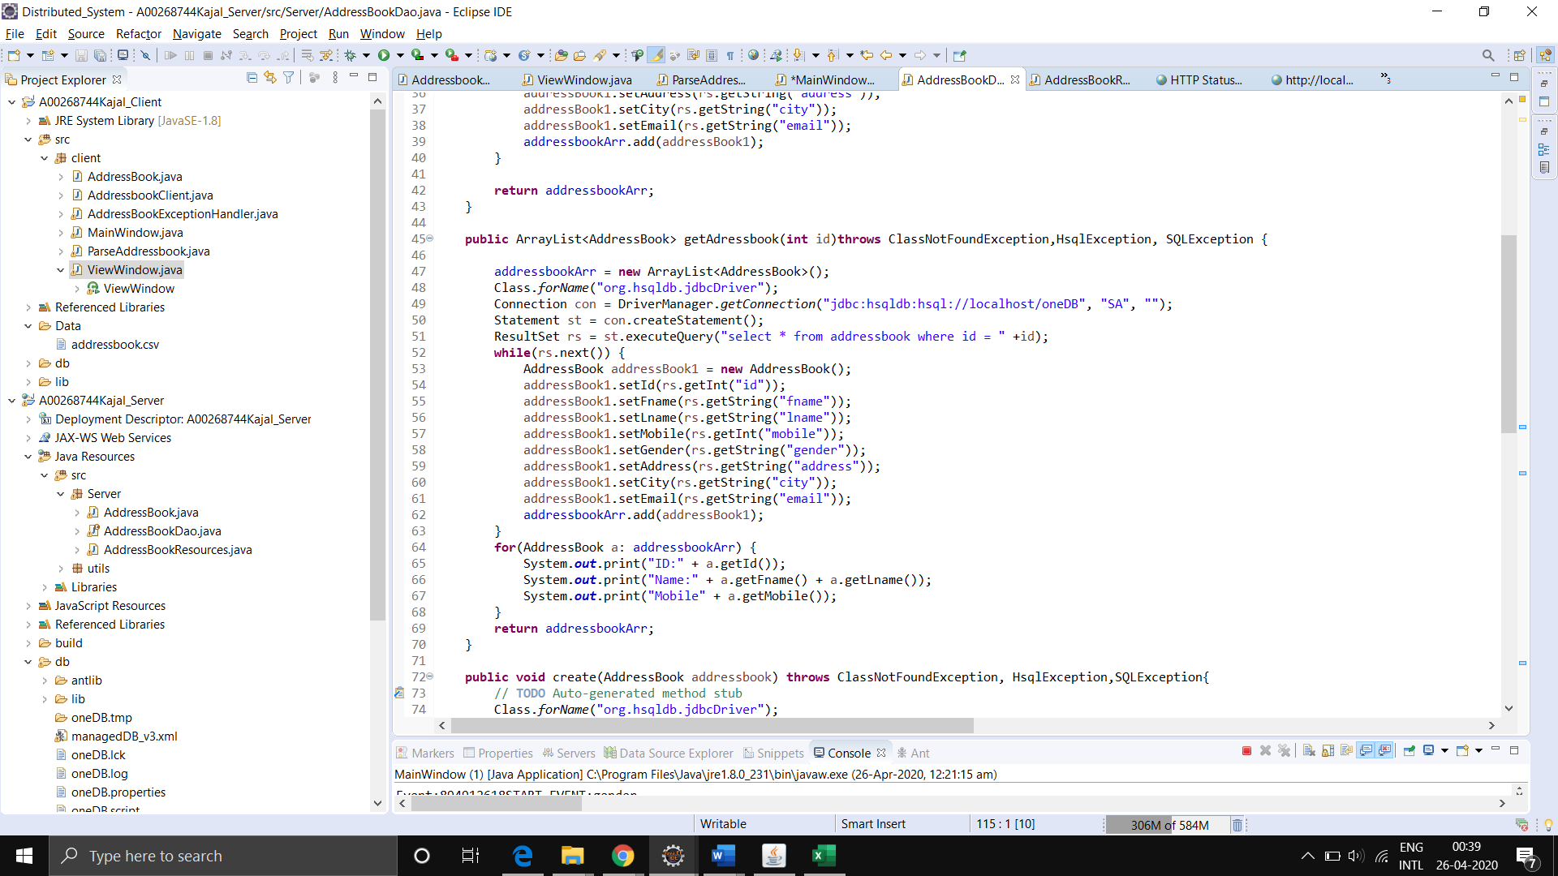

So, we call the URL and get this data from the server. We parse it and display it in the GUI.

Similarly, we do this for all information stored in the table.

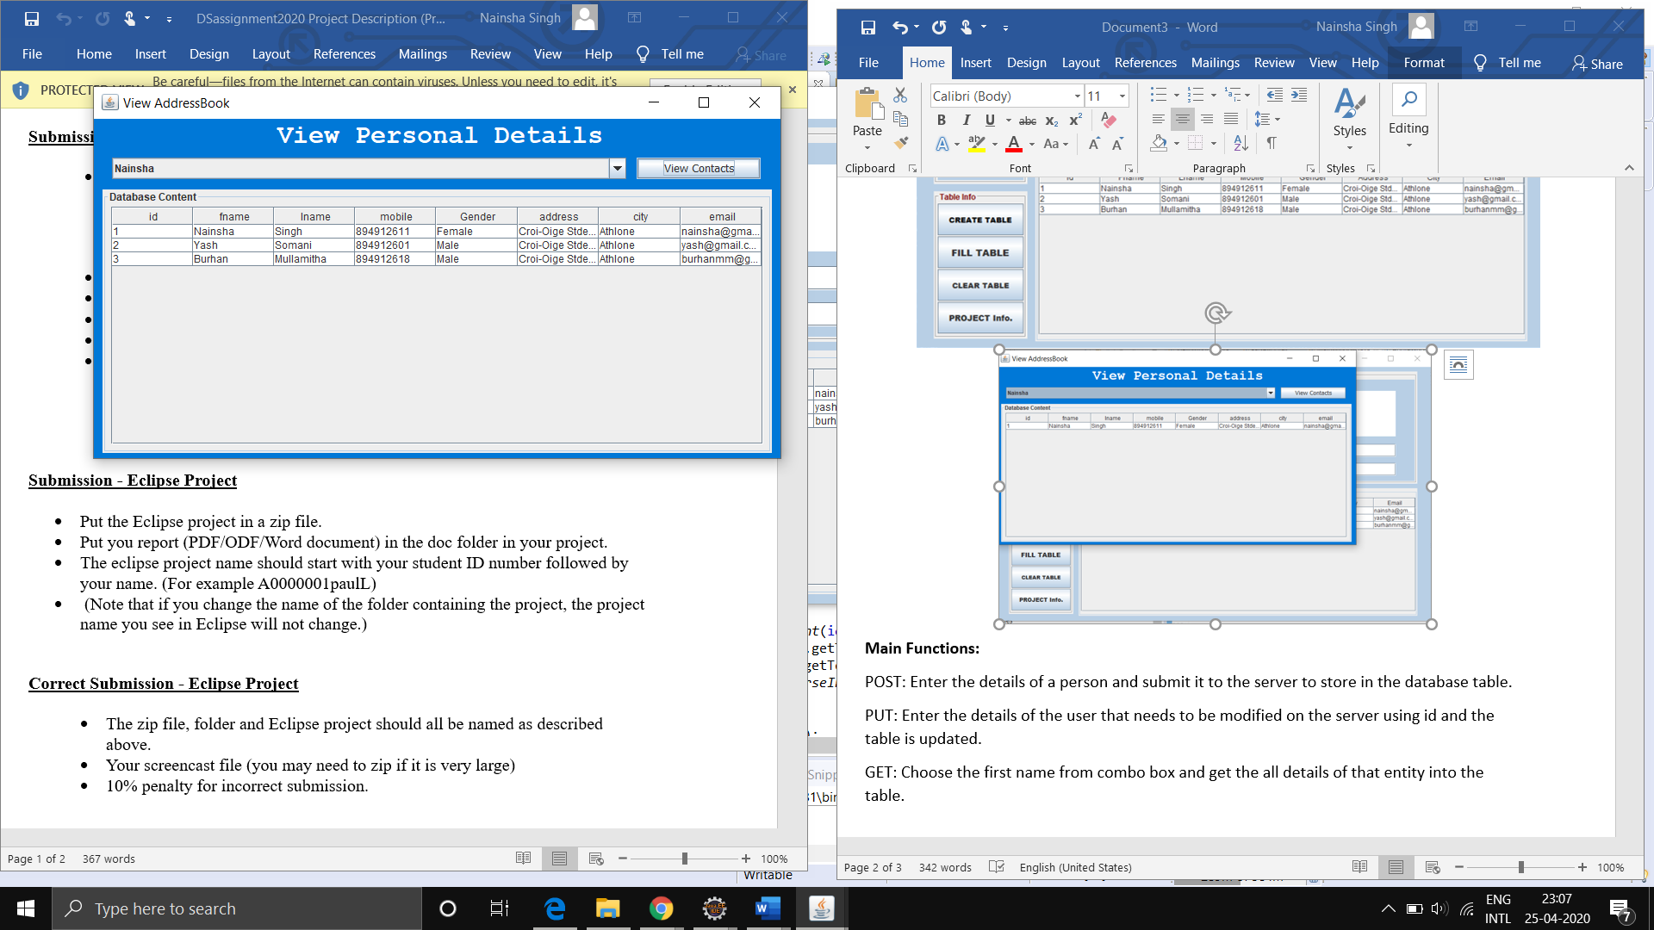

To view the data, we call the server with the HTTP GET Request and parse the data and display it in the table on the GUI Application.

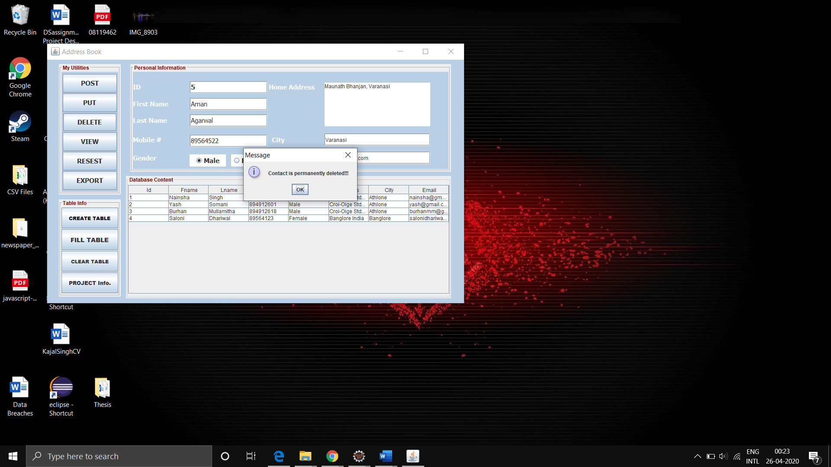

Here, the user gets to see which data he/she is planning to delete and after clicking on the button, a HTTP Delete Request is made by passing the ordered as a path parameter.

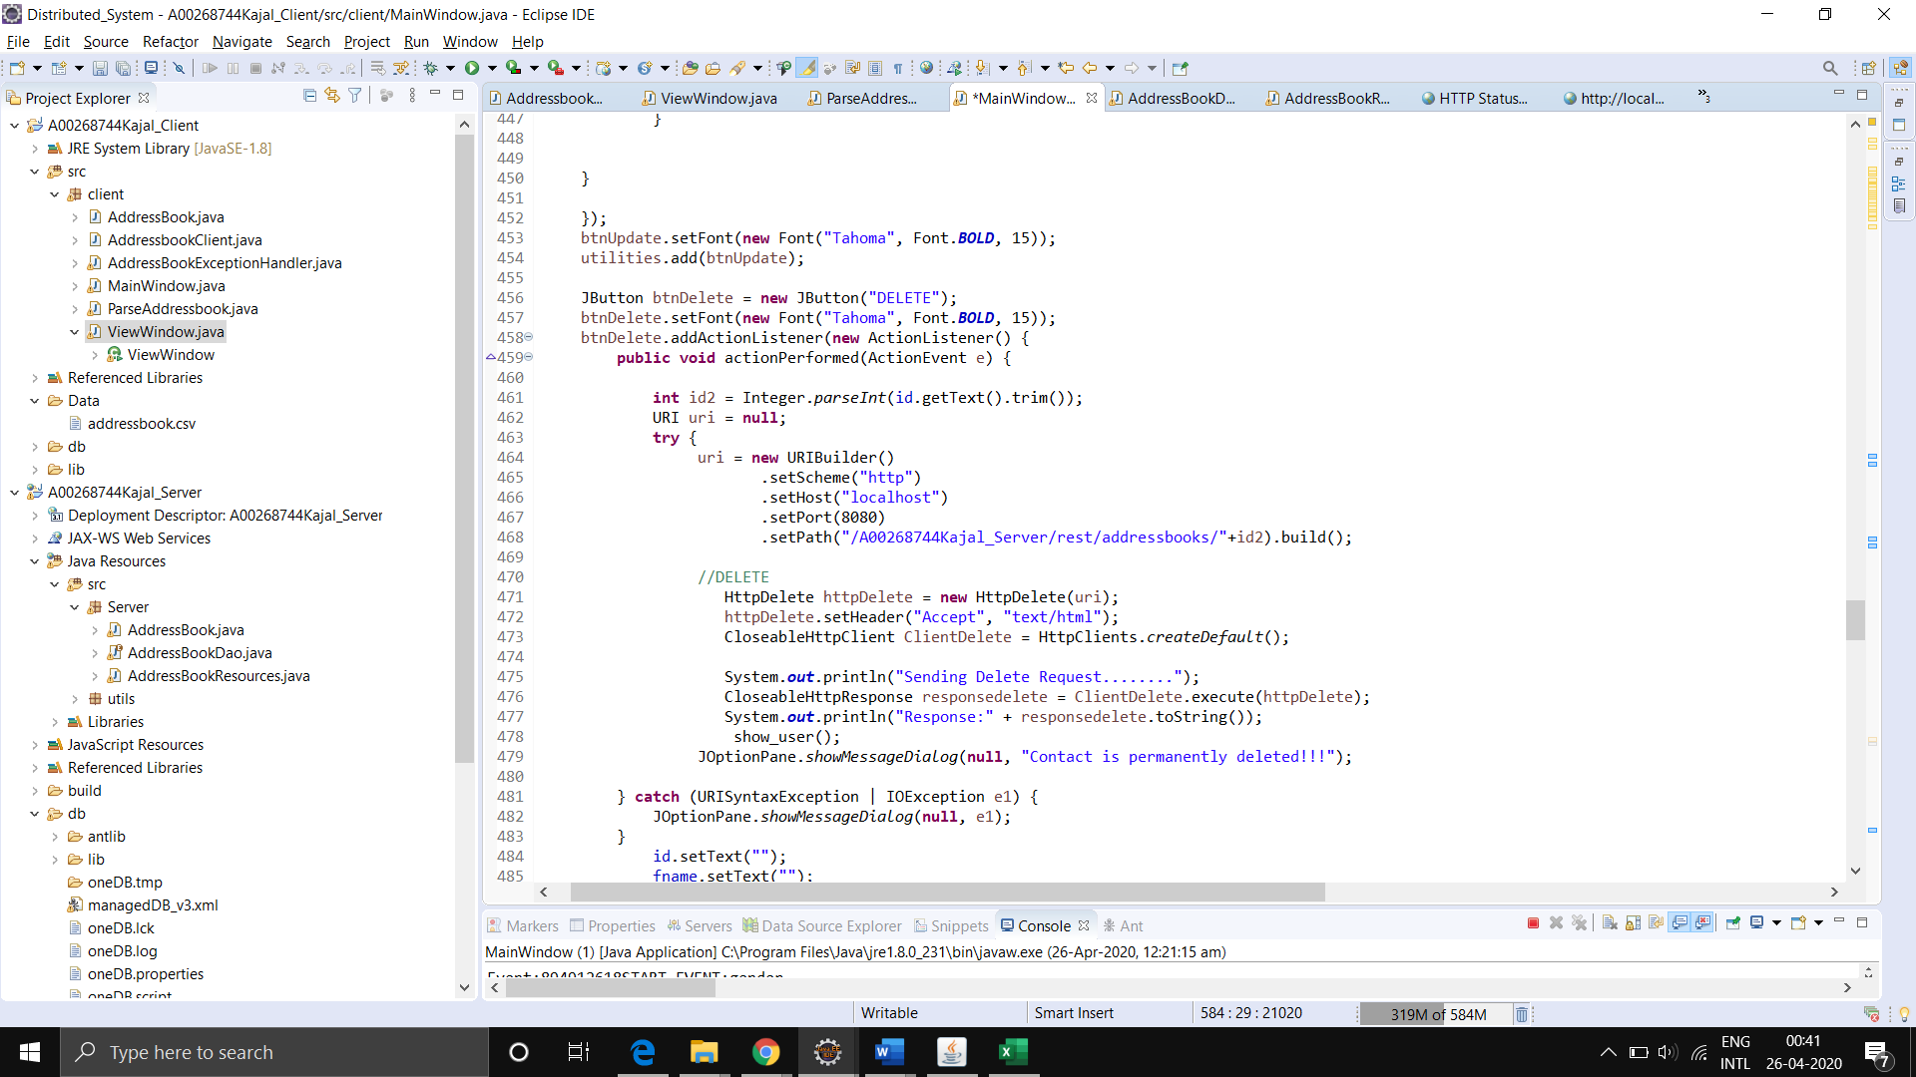

Most screenshots of the GUI have already been included but there are some extra features that will be highlighted here.

**Alerts**

If a user tries to call a command without entering all the inputs they need to a popup box is displayed and no call is made

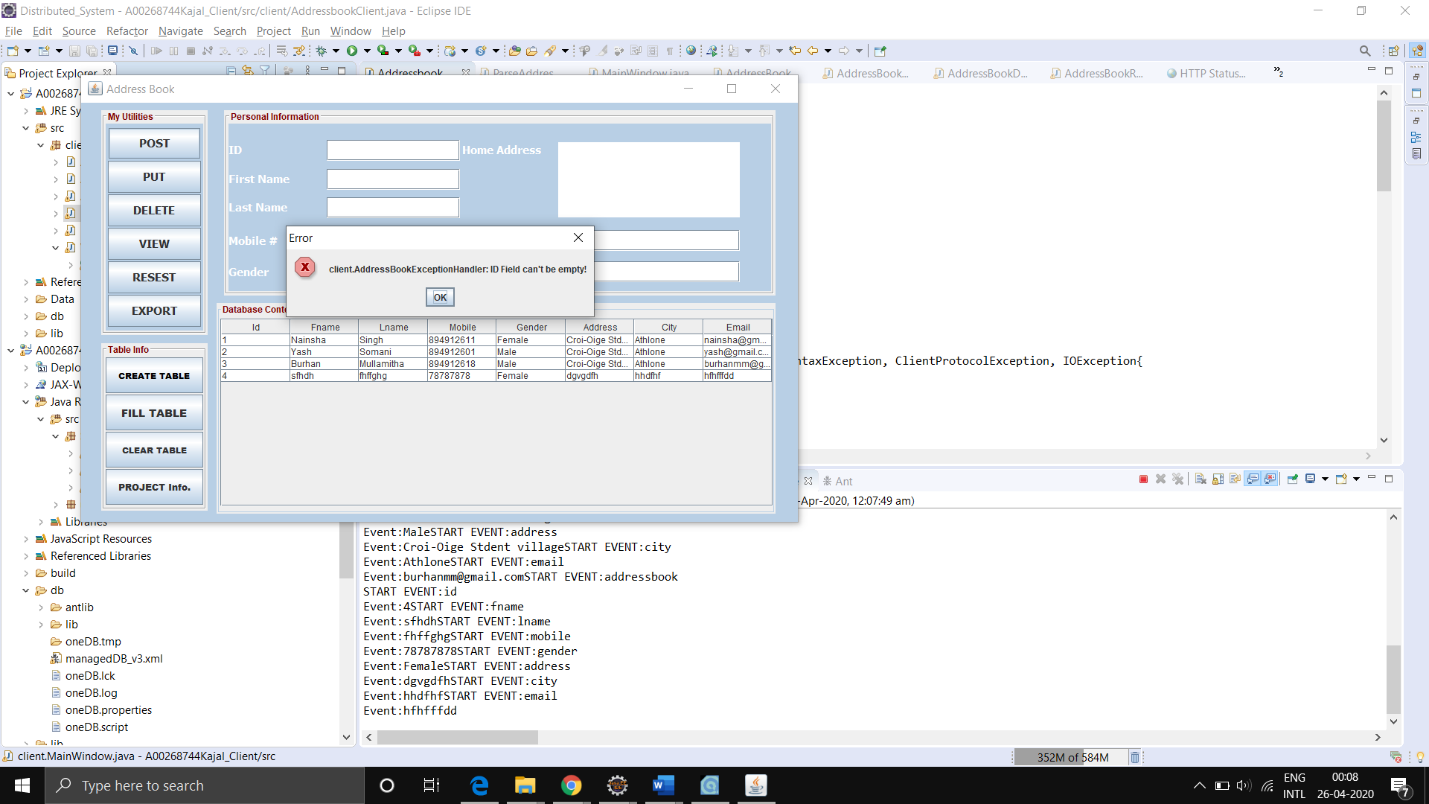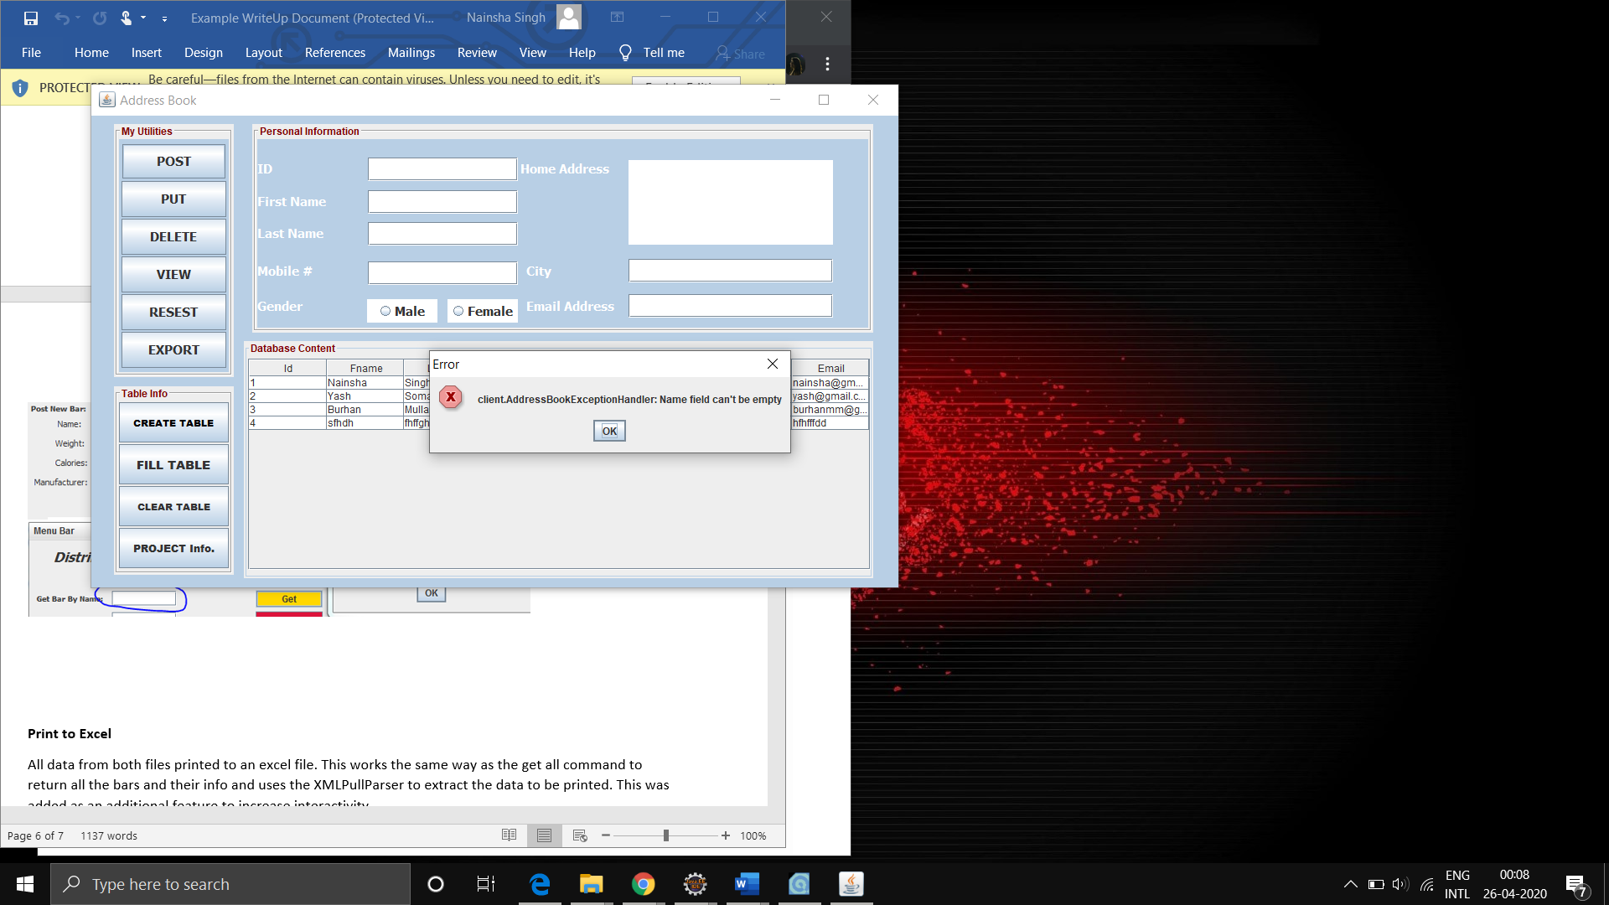

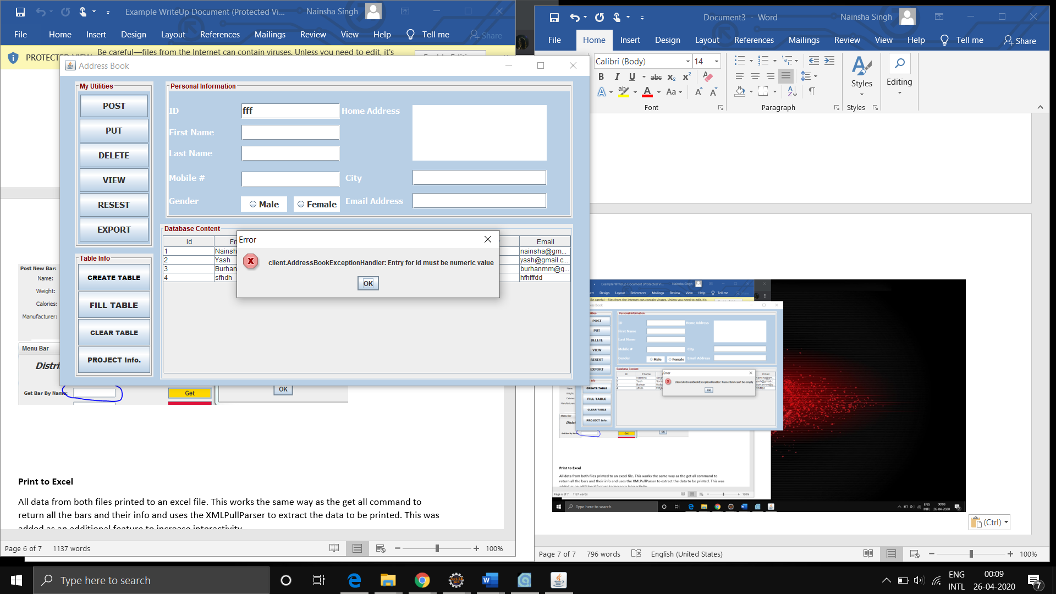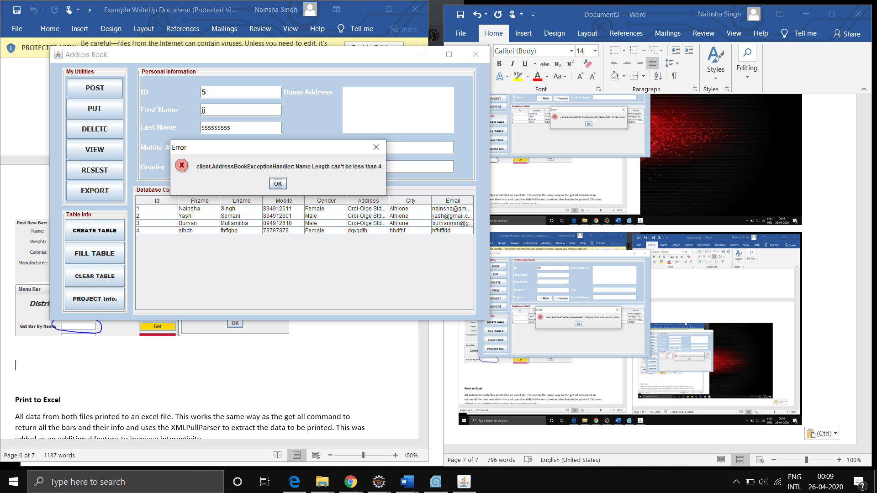

As you can see, I have used exception handler to throw exceptions whenever you submit the blank fields, whenever you put string value in id field, and name length should be greater than 4 always.

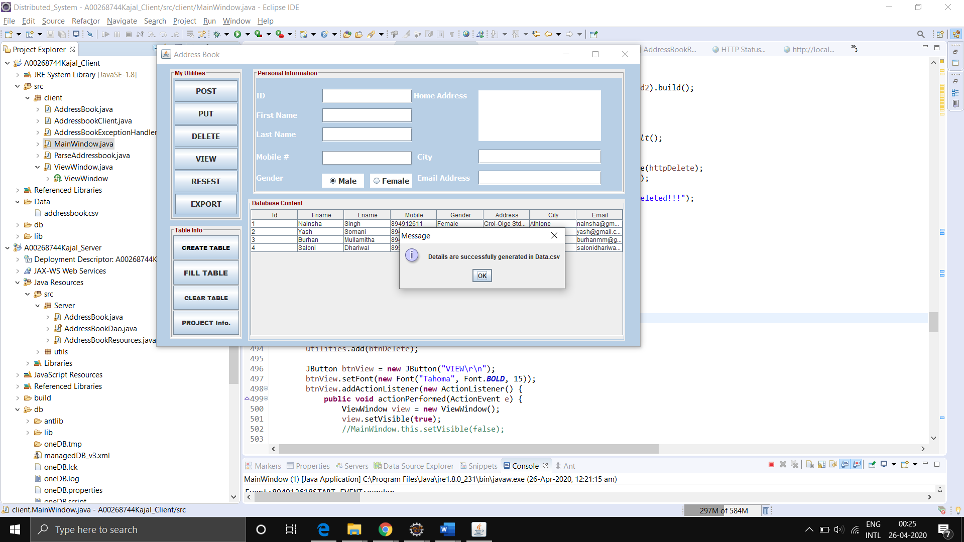

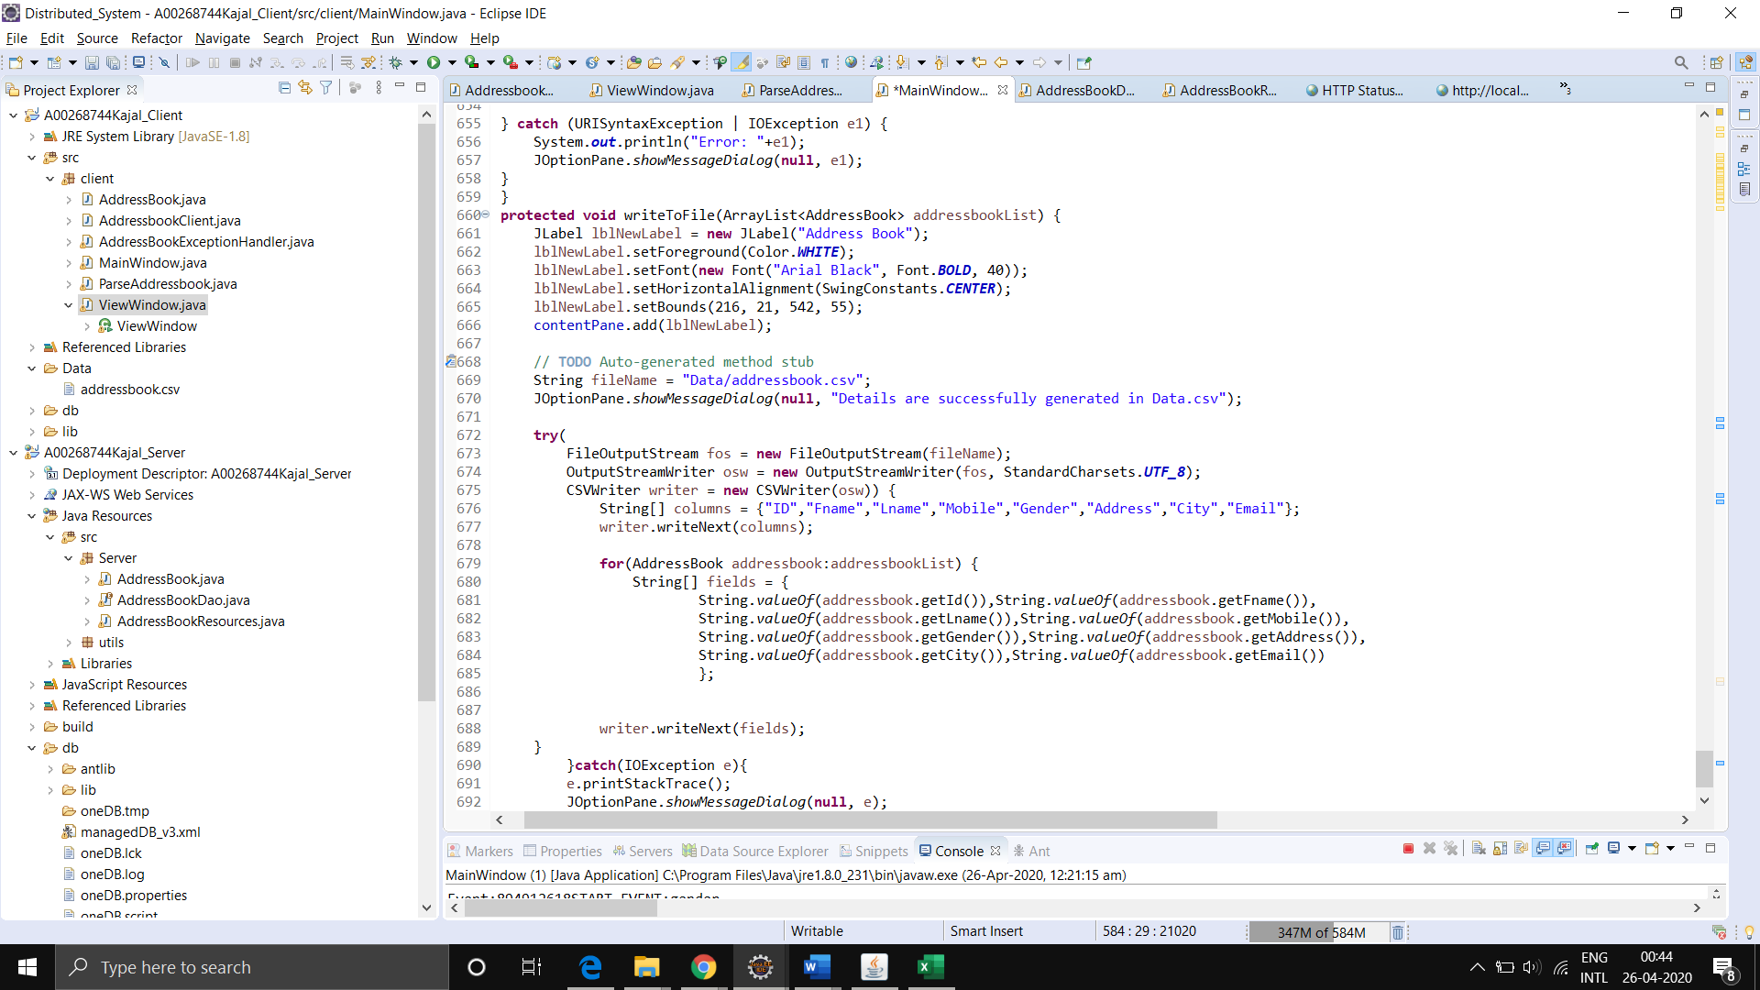

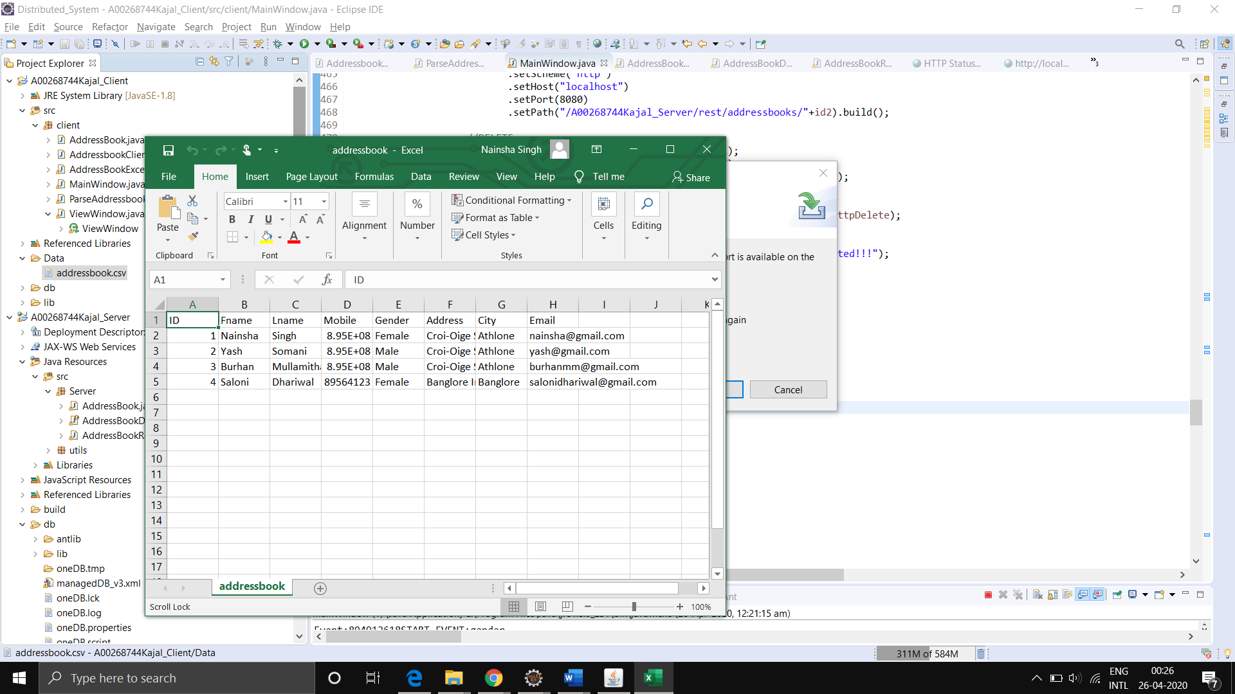

All data from files printed to an excel file. This works the same way as the get all command to return all the bars and their info and uses the XMLPullParser to extract the data to be printed. This was added as an additional feature to increase interactivity.

**Screencast Link:**

<https://studentait-my.sharepoint.com/:v:/r/personal/a00268744_student_ait_ie/Documents/SemII/Distributed_System/Screencast.mp4?csf=1&web=1&e=dCAWLu>